Melbourne International Comedy Festival presents
PAUL FOOT – Image Conscious
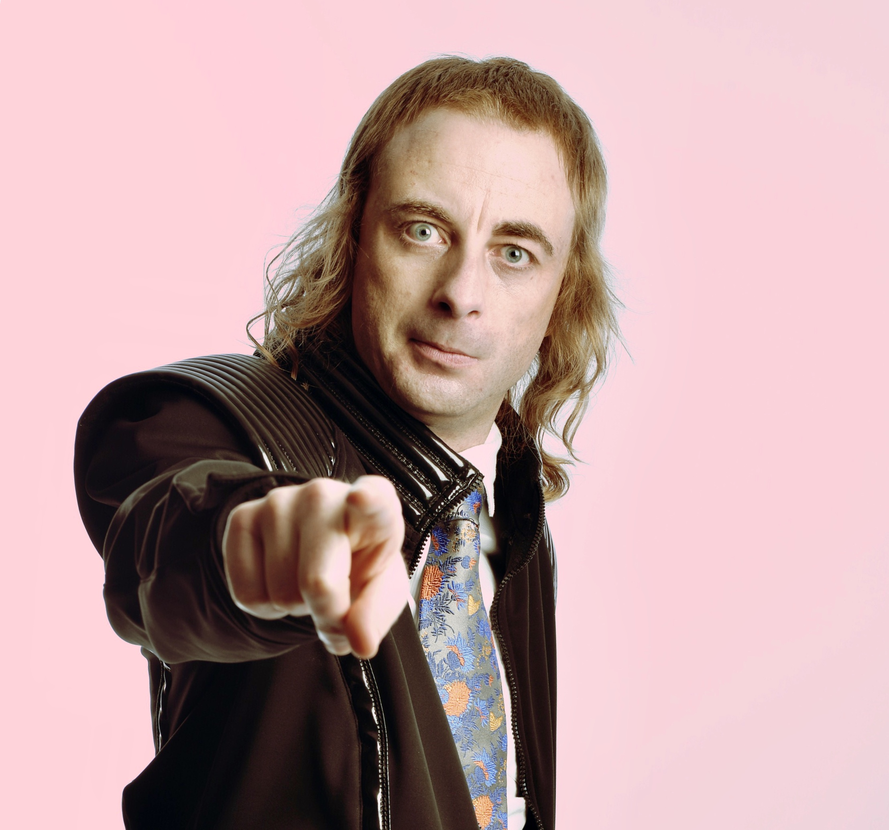

Prepare yourself for a brand-new show from critically acclaimed and multi award-winning comedian Paul Foot. Returning to NZ , Foot continues to mix surreal humour with eccentric disturbances.
In his own words: ‘Greetings! It's my brand-new show, baybayyy! Ever considered the unique predicament of the soft-shell crab? I have. What about the numerous problems of organising a suburban orgy? The catering, for example. It's an absolute nightmare!’
17 years after trying stand-up comedy in a little bar Paul Foot became an overnight success. And now he’s here – absurd and well dressed – for your viewing pleasure.
‘A deranged genius’ ★★★★ Sydney Morning Herald
‘Surreal and frenzied… a joy to experience, comedy craft of the highest order’ ★★★★ Broadway Baby
‘An exquisite symphony of jubilant madness’ ★★★★ The Age
Watch Paul here.

Paul Foot – Image Conscious
Auckland  Dates: Fri 3 & Sat 4 May, 8.30pm  Venue: Herald Theatre, Aotea Centre  Tickets: $30-32  Bookings: ticketmaster.co.nz // 09 970 9700 | Wellington  Dates: Mon 6 May, 8.30pm  Venue: Te Auaha  Tickets: $27 – $29  Bookings: iticket.co.nz // 0508 ITICKET

For more information, images and interviews contact:
Rebecca Austin at Melbourne International Comedy Festival | +61 3 9245 3700 | rebecca@comedyfestival.com.au

